Java 3 Activity 4 Task 1

30003389 – Kyer Potts

Table of Contents

Table of Contents i

You need to create a method that takes in a string and prints the string backwards. Below is a template of the method. Complete the method so it works as intended. 2

What is the major difference between making modifications to a String and a StringBuilder? 2

# You need to create a method that takes in a string and prints the string backwards. Below is a template of the method. Complete the method so it works as intended.

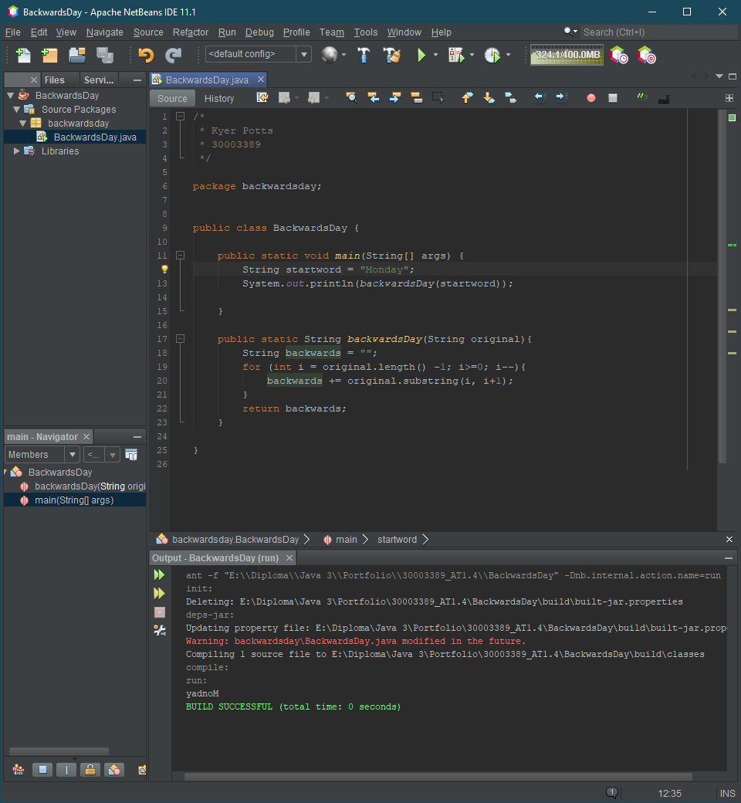

# What is the major difference between making modifications to a String and a StringBuilder?

Once strings are created, it will be immutable. It cannot be changed with modifications, it is instead replaced with a new string. A StringBuilder allows the string to be modified without having to completely replace the string. This cuts down on memory allocation and garbage collection. StringBuilder objects contain methods for altering, removing characters, appending characters or completely replacing the string without having to allocate additional memory resources.